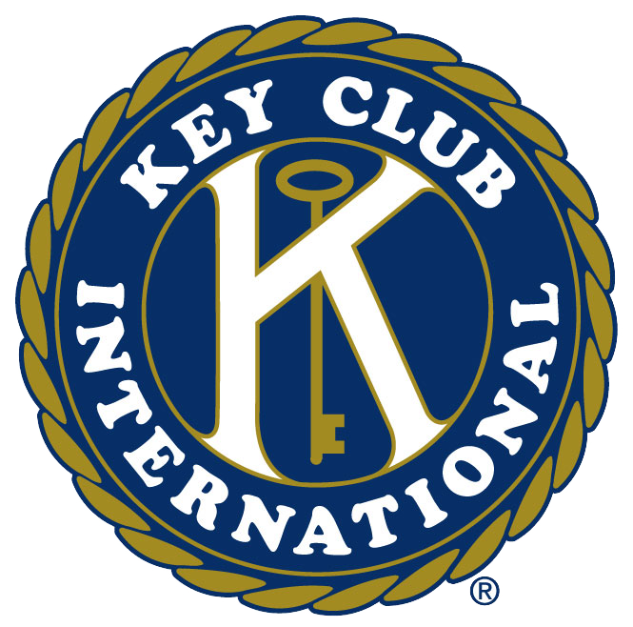

Enochs Key Club Contact Form

Last Name, First
Email
Preferred Phone
Mailing Address
City
Graduation Year
Committee

*Our club plans on having two committees, an event committee and a spirit committee, and members of these committees are considered to have a leadership position. People on the event committee will be able to create their own events and fundraisers with help from the officers. The spirit committee will be in charge of things such as making spirit gear, posters, advertisements, decorating events, and various other jobs. Being apart of these committees does not force members to do extra work, but allows them to be more involved in the club, and they help members possibly earn a reward at the end of the year as well!

